**Western Australian Certificate of Education**

**Semester One Examination, 2020**

**Question/Answer Booklet**

|  |  |  |  |
| --- | --- | --- | --- |
|  | **Total** | **Result** | **_____%** |
| **Section One** | **52** |  |
| **Section Two** | **98** |  |
| **Total** | **150** |  |

**MATHEMATICS**

**METHODS**

**UNIT 1&2**

**Section One:**

**Calculator- free**

**Student’s Name**: **_______________________________________**

**As shown on your exam timetable**

**Student’s Teacher Mr Bellis Mrs Dalby**

(**Circle your teacher’s name**.)

**Mr Hughes Mrs Potier**

**Time allowed for this section**

Reading time before commencing work: five minutes

Working time for this section: fifty minutes

**Materials required/recommended for this section**

***To be provided by the supervisor***

This Question /Answer Booklet

Formula Sheet

***To be provided by the candidate***

Standard Items: pens (blue/black preferred), pencils (including coloured), sharpener,

correction fluid/tape, eraser, ruler, highlighters.

Special items: nil.

**Important note to candidates**

No other items may be taken into the examination room. It is **your** responsibility to ensure

that you do not have any unauthorized notes or other items of a non-personal nature in the

examination room. If you have any unauthorized material with you, hand it to the supervisor

**before** reading any further.

|  |  |  |  |  |  |  |
| --- | --- | --- | --- | --- | --- | --- |
| Section | Number of questions available | Number of questions to be answered | | Working time (minutes) | Marks available | Percentage of exam |
| Section One:  Calculator-free | 8 | 8 | | 50 | 52 | 35 |
| Section Two:  Calculator-assumed | 13 | 13 | | 100 | 98 | 65 |
|  | | | **Total** | | 150 | 100 |

## Instructions to candidates

1. The rules for the conduct of examinations are detailed in the *School Examination Rules* provided with your exam timetable.Sitting this examination implies that you agree to abide by these rules.
2. Write your answers in this Question/Answer booklet preferably using a blue/black pen.

Do not use erasable or gel pens.

1. You must be careful to confine your responses to the specific questions asked and to follow any instructions that are specific to a particular question.
2. Spare pages are included at the end of this booklet. They can be used for planning your responses and/or as additional space if required to continue an answer.

* Planning: If you use the spare pages for planning, indicate this clearly at the top of the page.
* Continuing an answer: If you need to use the space to continue an answer, indicate in the original answer space where the answer is continued, i.e. give the page number. Fill in the number of the question(s) that you are continuing to answer at the top of the page.

1. **Show all your working clearly**. Your working should be in sufficient detail to allow your answers to be checked readily and for marks to be awarded for reasoning. Incorrect answers given without supporting reasoning cannot be allocated any marks. For any question or part question worth more than two marks, valid working or justification is required to receive full marks. If you repeat an answer to any question, ensure that you cancel the answer you do not wish to have marked.
2. It is recommended that you **do not use pencil**, except in diagrams.
3. The formula sheet and your notes are **not to be handed** in with your Question/Answer Booklet.

Section One: Calculator-free 35% (52 Marks)

This section has**eight** questions. Answer **all** questions. Write your answers in the spaces provided.

Working time: 50 minutes.

Question 1 (5 marks)

The point $M(-2, 5)$ is the midpoint of point $A(-6, 3)$ and point $B$.

(a) Determine the coordinates of point $B$. (2 marks)

(b) Determine the equation of the straight line that passes through point $C(4, -1)$ and is perpendicular to the line through points $A$ and $M$. (3 marks)

Question 2 (4 marks)

Expand and simplify the following.

(a) ${\left(x-9\right)}^{2}$. (1 mark)

(b) $(2x+1)(x-3)(x+7)$. (3 marks)

Question 3 (5 marks)

Functions $f$ and $g$ are defined by $f\left(x\right)=4x^{2}-4x+5$ and $g\left(x\right)=2x^{2}-8x+6$.

(a) Determine the discriminant of $f$ and the discriminant of $g$. (2 marks)

(b) State, with justification, which function has no zeros and determine all zeros of the other function. (3 marks)

Question 4 (7 marks)

(a) Sketch the graph of $y^{2}=x$ on the axes below. (2 marks)

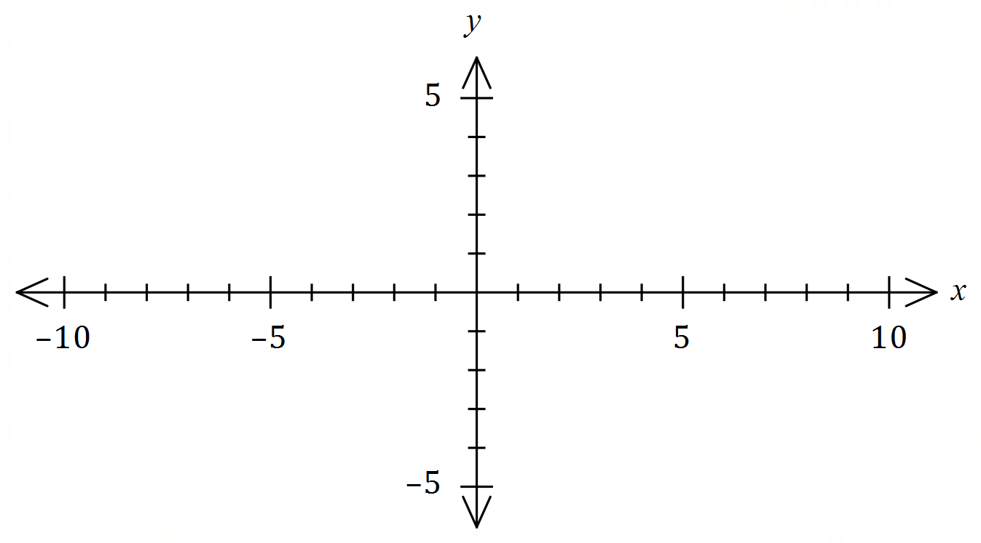

(b) Sketch the graph of ${\left(x+1\right)}^{2}+{\left(y-1\right)}^{2}=4$ on the axes below. (3 marks)

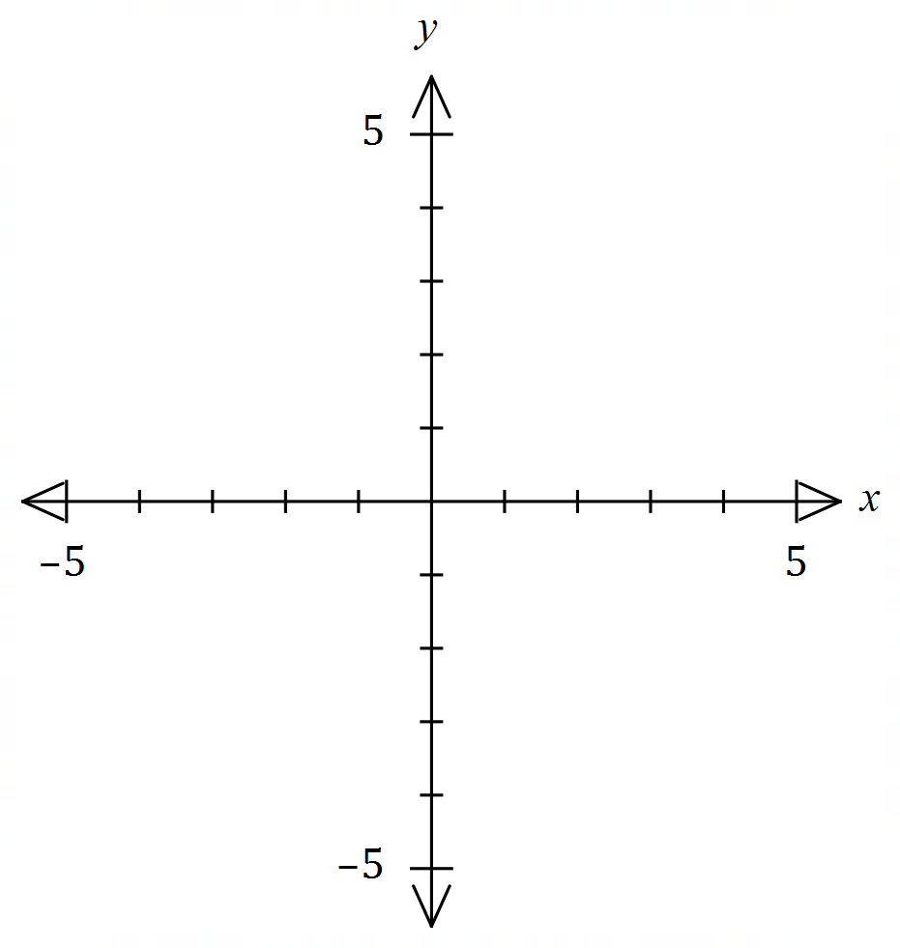

(c) Explain whether $y$ is a function of $x$ in the relationship graphed in (a). (2 marks)

Question 5 (8 marks)

(a) A periodic function is defined by $f\left(x\right)=2-2\sin{(3x)}$.

(i) State the amplitude of the function. (1 mark)

(ii) State the period of the function in degrees. (1 mark)

(iii) Sketch the graph of $y=f(x)$ on the axes below. (3 marks)

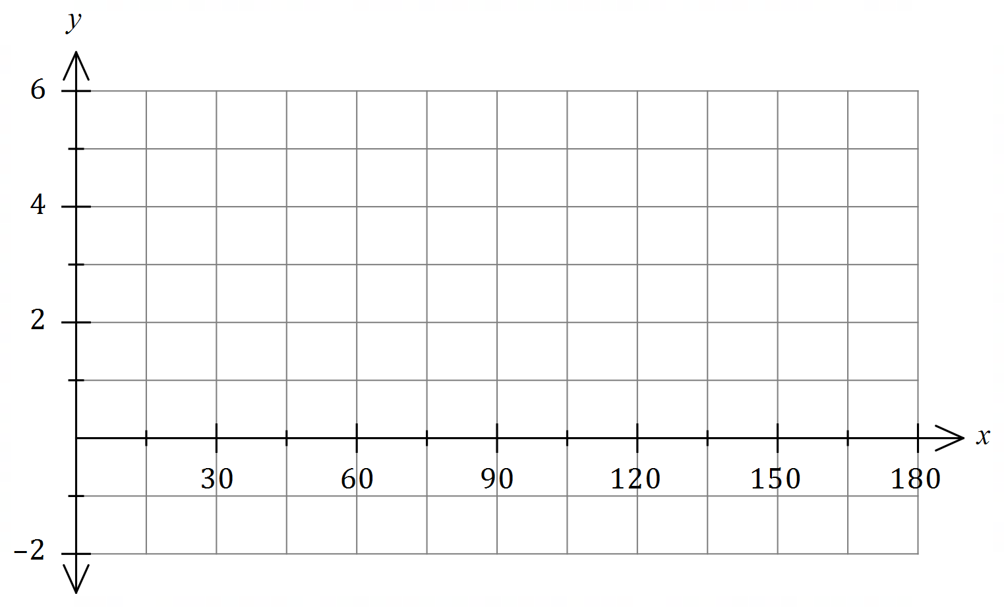

(b) Solve the equation $2\cos{(x-15°)}=\sqrt{3}$ where $0≤x≤360°$. (3 marks)

Question 6 (7 marks)

(a) The variable $V$ is inversely proportional to the variable $t$, so that when $t=3.6$, $V=10$.

(i) Explain how $V$ will change as $t$ increases. (1 mark)

(ii) Determine $t$ when $V=3$. (2 marks)

(b) Part of the graph of $y=\begin{matrix}a \\ \overline{x+2}\end{matrix}$ is drawn below.

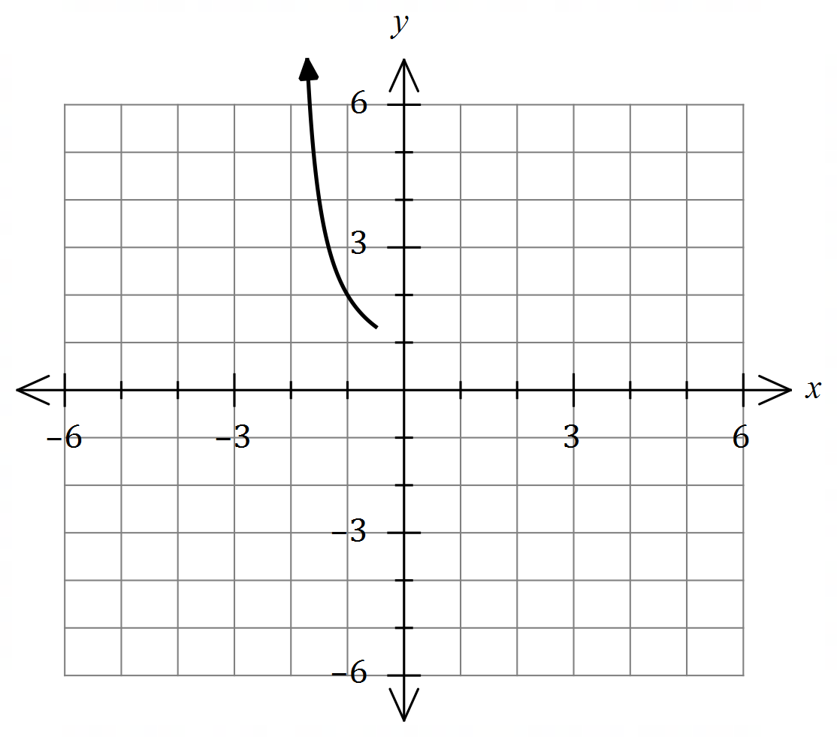

(i) Determine the value of $a$. (1 mark)

(ii) Draw the remainder of the graph. (3 marks)

Question 7 (8 marks)

Solve the following equations for $x$.

(a) $x^{2}+20x-21=0$. (2 marks)

(b) ${\left(x-1\right)}^{2}-4=2x-3$. (3 marks)

(c) $x^{3}-2x^{2}-11x+12=0$. (3 marks)

Question 8 (8 marks)

(a) Determine an exact value for $\cos{103°}\cos{58°}+\sin{103°}\sin{58°}$. (2 marks)

(b) Determine all possible values of $\tan{θ}$ when $\sin{θ}=\begin{matrix}2 \\ \overline{3}\end{matrix}$. (3 marks)

(c) Determine an exact value for $\sin{75°}$. (3 marks)

**Additional working space.**

**Question Number _________**

**Additional working space.**

**Question Number: _________**